WAF testing: what the results actually show
  - Group 11 | COMP6016 | Comparative results and evidence guide

What we set out to check
We wanted to understand how well open-source web application firewalls deal with ordinary requests and deliberate attack traffic. We also wanted to see whether changing the presentation of a payload — for example through double encoding — affected detection. A useful comparison needs to consider missed attacks, false alarms on normal traffic and recorded response times, rather than focusing on blocking percentages alone.
The archive contains two separate sets of experiments. The automated framework compares the baseline, ModSecurity and Coraza in attack-only and mixed-traffic runs. Bishal’s reviewed payload tests compare ModSecurity and NAXSI on matched labelled requests. These are reported separately because the traffic and classification methods are different.

The results in brief
Question | What we found
Which WAF caught more in the reviewed payload study? | ModSecurity blocked 1,564 of 1,564 malicious test requests. NAXSI blocked 1,310 and missed 254.
Where did the reviewed misses occur? | 120 double-encoded XSS, 92 double-encoded SQL injection and 42 path-traversal requests were missed by NAXSI.
What about ordinary requests? | In the reviewed experiment, ModSecurity wrongly blocked 11 of 120 benign requests; NAXSI blocked 12 of 120.
How close were ModSecurity and Coraza? | Both recorded approximately 35% clean-block rates in the separate automated experiments. The differences were small.
Was either definitely faster? | ModSecurity recorded lower mean response times than Coraza in the available automated summaries, but this does not isolate firewall overhead.

How the testing was carried out

A. Automated traffic framework
The group framework sent requests through baseline, ModSecurity and Coraza configurations under attack-only and mixed-traffic phases. Its request records captured the type of attack, HTTP result and elapsed time. The grouped results distinguish requests recorded as blocked, allowed, redirected or resulting in server errors. Setup/login traffic is not treated as evaluated benign traffic in the resulting summaries.

B. Reviewed payload comparison
The second experiment used 1,684 matched cases against each of ModSecurity and NAXSI: 1,564 malicious and 120 benign. The outcome labels were reviewed as true positive, false negative, false positive or true negative. The reviewed package also references WAF and backend logs. We use those labels when describing the 254 confirmed misses in that particular dataset.
We did not treat an HTTP 500 response as proof that a WAF blocked a request. We also did not count an allowed malicious request as a confirmed compromise of the protected application.

Reviewed matched tests: ModSecurity and NAXSI
Measurement | ModSecurity | NAXSI
Malicious requests | 1,564 | 1,564
Blocked malicious (TP) | 1,564 | 1,310
Missed malicious (FN) | 0 | 254
Detection rate | 100.00% | 83.76%
Benign requests | 120 | 120
Benign incorrectly blocked (FP) | 11 | 12
False-positive rate | 9.17% | 10.00%
The most notable difference was not between normal and URL-encoded payloads, where both products often blocked the tested requests. It appeared in a narrower group of changed payloads: double-encoded SQL injection, double-encoded XSS and baseline path traversal. That makes payload representation an important finding, but the CSVs alone do not establish the exact underlying rule or decoding fault.
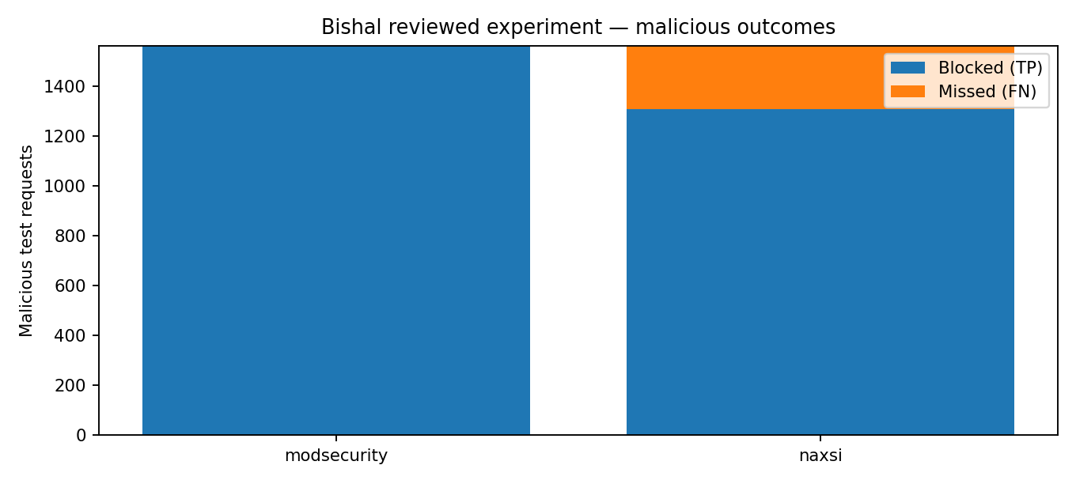

Where the 254 misses came from
Payload condition | NAXSI missed | What this means
Double-encoded XSS | 120 | None of these 120 labelled malicious cases was blocked.
Double-encoded SQL injection | 92 | 28 of 120 were blocked; 92 were missed.
Path traversal | 42 | 78 of 120 were blocked; 42 were missed.
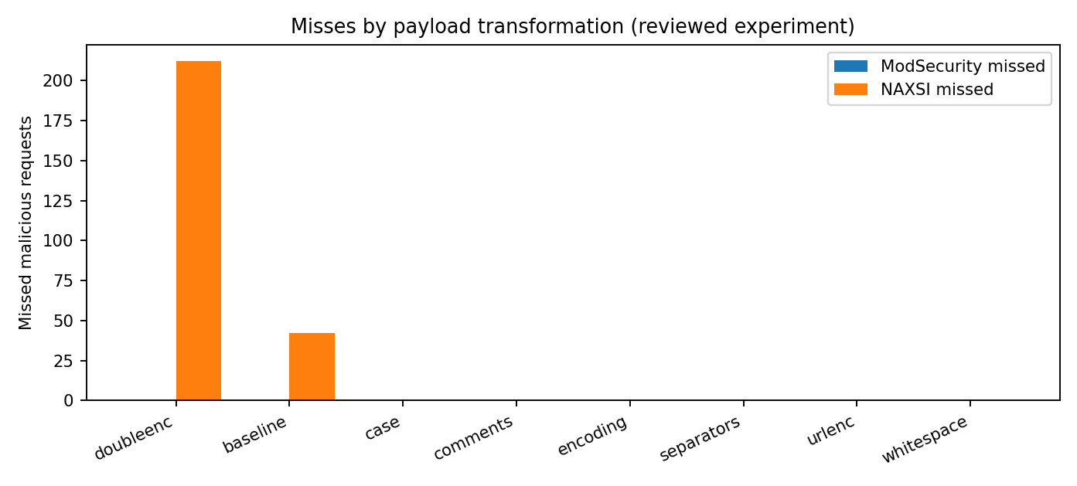

Automated framework: ModSecurity and Coraza
The automated results give a rather different picture. ModSecurity and Coraza recorded closely matched clean-block rates. In attack-only traffic the figures were 34.84% and 34.77% respectively; in mixed traffic they were 34.95% and 35.07%. The gap is small, and these results do not support claiming that either engine is universally more effective.
Traffic phase | ModSecurity | Coraza
Attack only | 34.84% | 34.77%
Mixed traffic | 34.95% | 35.07%
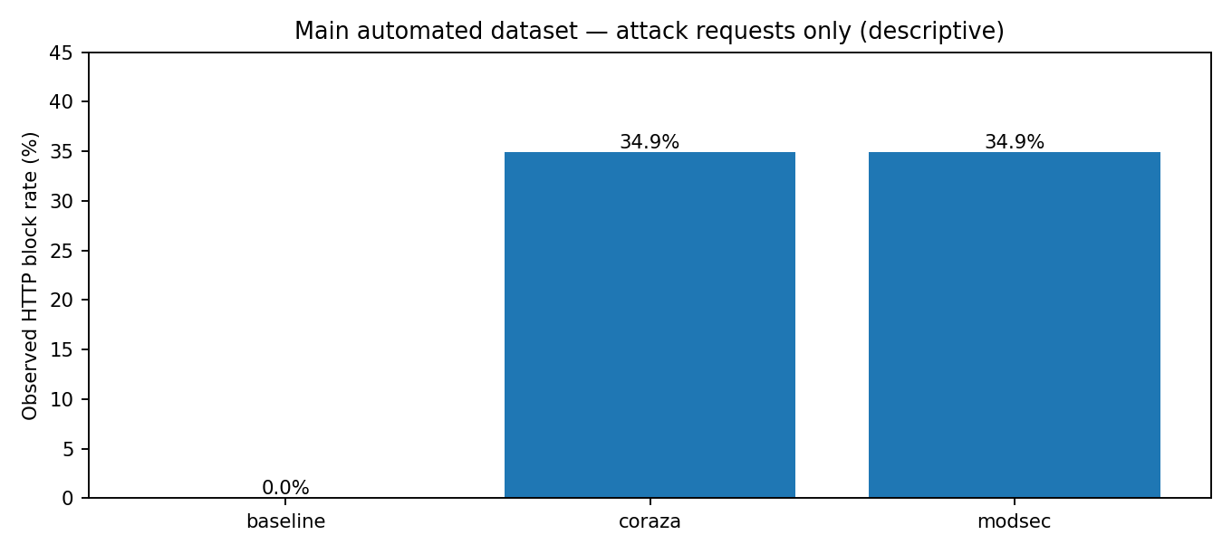
The baseline is a reference run without the tested protection, not another WAF. Recorded response times were lower for ModSecurity than Coraza in the available averages, but traffic conditions, application processing and WAF deployment may all contribute to the total time.

Benign traffic: why it matters
Blocking attacks is only half the problem. A firewall can also disrupt legitimate customers by flagging harmless requests. In Bishal’s labelled benign sample, 11 requests were incorrectly blocked by ModSecurity and 12 by NAXSI. That is a small numerical difference; we should describe it, not exaggerate it. The automated mixed-traffic dataset recorded no benign blocks for ModSecurity or Coraza under its own evaluated definition. Those two findings concern different traffic samples.
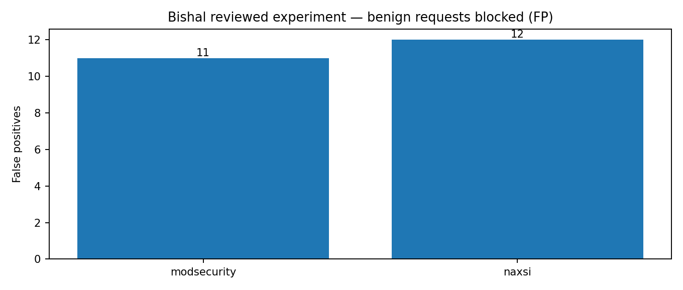

Where each CSV fits
File | Best use
01_Grouped_Test_Results.csv | Main category-by-category evidence, with counts and source paths.
02_Traffic_Overview.csv | A one-glance summary of malicious and benign traffic in each run.
03_Missed_Attacks.csv | Locate categories with malicious requests not recorded as blocked.
04_Benign_Traffic.csv | Discuss false alarms and their effect on legitimate requests.
05_Payload_Transformations.csv | Explain baseline, encoded and modified attack comparisons.
06_ModSecurity_Coraza.csv | Compare the two WAFs within matched automated conditions.

Conclusions
For the reviewed payload corpus, ModSecurity did better than NAXSI at blocking the selected attacks, particularly double-encoded XSS and SQL injection. For the automated workload, ModSecurity and Coraza were much closer. The difference between these findings is not a contradiction: the two experiments used different workloads and should not be combined into a single ranking.
Our strongest defensible conclusion is that performance depends on the attack category, payload representation, rules and test configuration. The results identify missed blocks and useful follow-up targets. They do not demonstrate successful exploitation of every allowed request or isolate a specific cause for every missed detection.

Attribution and evidence boundaries
These tables consolidate tests originally carried out by the project contributors. The consolidated report is a secondary comparison and evidence organisation exercise, not a claim that one person performed all original tests.
For an audit, work backwards from the grouped CSV to its source_file field, then to the original detailed record and any available WAF or application logs. The detailed file is included in this package to make that possible.

